**GUI Descriptions:**

The main interface consists of four tabs, denoted both visually with an icon and with a textual label.

Contacts Tab:

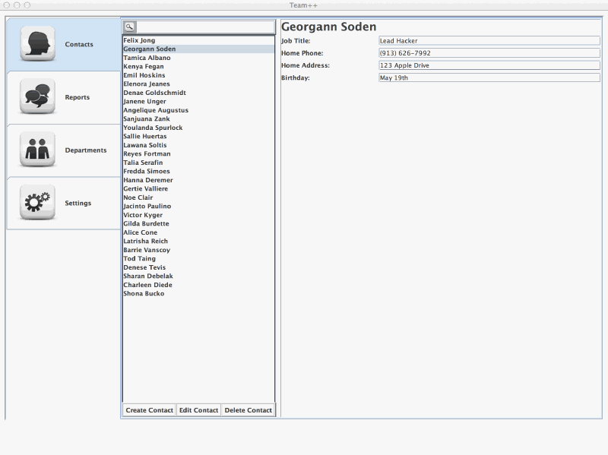

Under the Contacts tab, the user is presented with a list of users in the left pane, and the selected user's information in right. On the top of the left contacts pane is a text field which allows the user to search for an existing contact. This bar filters the users below in real time, narrowing the results dynamically as they are typed.

When a user's name is selected from the list, the user's information is immediately displayed in the rightmost pane. At the bottom of the left contacts pane rests a toolbar containing a button for creating a new contact. When this button is clicked by the user, the pane to the right is populated with editable fields, which can be used to input information about the employee.

Reports Tab:

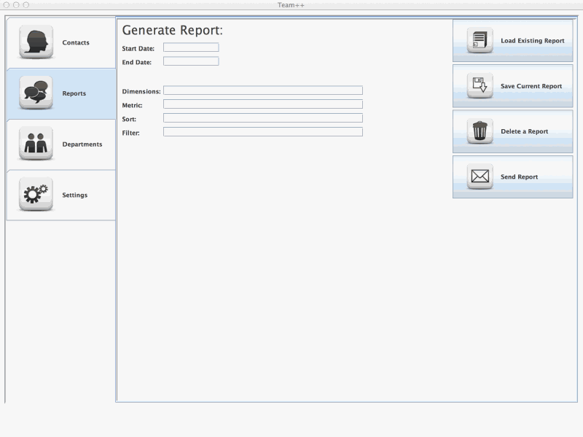

Under the Reports tab the user is presented with a single panel. On the left-hand side of this panel exists the user editable text fields. One of these exists for each parameter: From top to bottom:

* Start Date
* End Date
* Dimensions
* Metric
* Sort
* Filter

On the right-hand side of this panel the user will find four buttons. From top to bottom, these are:

* Load Existing Report: This opens up a popup panel that contains a list of existing reports saved on the SQL server. When a report is chosen, the leftmost information fields will be populated with its contained data.
* Save Current Report: This opens up a popup panel that again contains a list of existing reports saved on the SQL server. Now present is a text field in which a name for a new report can be added, and the user's fields will be stored to the server under the specified name.
* Delete a Report: This option opens up the same popup panel that contains a list of existing reports saved on the SQL server. This time a delete button is present allowing the user to delete a single or multiple selected reports from the server.
* Send Report: This button opens up a mail client like interface, allowing the user to select a previously saved report and specify recipients.

Departments Tab:

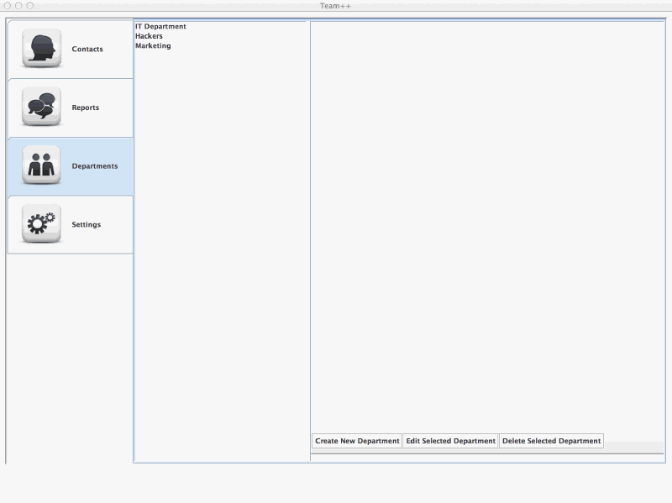

Under the Departments tab we find an interface very similar to the one under the contacts tab. It is again split into two panes, with the departments listed on the left and the department information listed on the right. The department information also includes the list of employees in the department. On the rightmost pane, there is a toolbar at the bottom containing three buttons. From left to right these are:

* Create New Department
* Edit Selected Department
* Delete Selected Department.

Settings Tab:

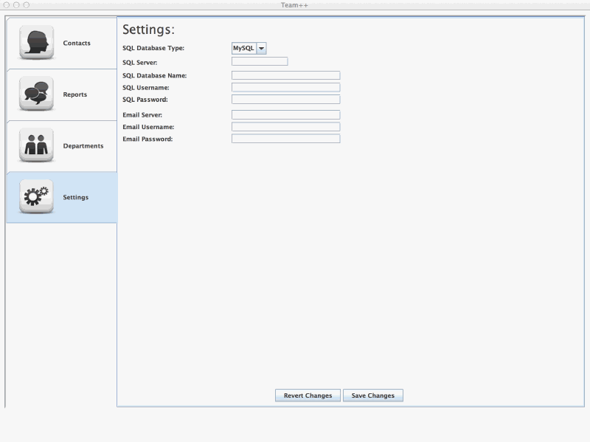

Finally, is the settings tab.

This tab contains user-editable text fields for email and SQL. It allows the user to dynamically edit SQL database type, name, and authentication credentials as well as SMTP server name and credentials. At the bottom are "Revert Changes" and "Save Changes" buttons.